**What is RAD Model?**

RAD Model or Rapid Application Development model may be a software development process supported prototyping with none specific planning. In RAD model, there's less attention paid to the design and more priority is given to the event tasks. It targets at developing software during a short span of your time.

**SDLC RAD modeling has following phases**

* Business Modeling
* Data Modeling
* Process Modeling
* Application Generation
* Testing and Turnover

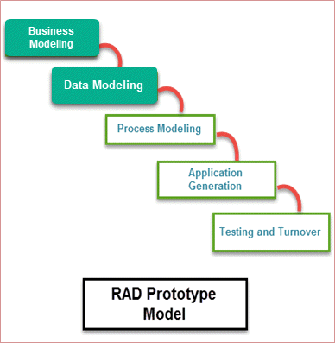

RAD Model Diagram

**Business Modeling**

On basis of the flow of data and distribution between various business channels, the merchandise is meant.

**Data Modeling**

The information collected from business modeling is refined into a group of knowledge objects that are significant for the business.

**Process Modeling**

The data object that's declared within the data modeling phase is transformed to realize the knowledge flow necessary to implement a business function.

**Application Generation**  
 Automated tools are used for the development of the software, to convert process and data models into prototypes.

**Testing and Turnover**  
 As prototypes are individually tested during every iteration, the general testing time is reduced in RAD.

## Rapid Application Development Advantages and Disadvantages:

|  |  |
| --- | --- |
| Advantages | Disadvantages |
| Flexible and adaptable to changes | It can’t be used for smaller projects |
| It is useful once you need to reduce the general project risk | Not all application is compatible with RAD |
| It is adaptable and versatile to changes | When technical risk is high, it's not suitable |
| It is easier to transfer deliverables as scripts, high-level abstractions and intermediate codes are used | If developers aren't committed to delivering software on time, RAD projects can fail |
| With less people, productivity are often increased briefly time | Requires highly skilled designers or developers |
| It is easier to transfer deliverables as scripts, high-level abstractions and intermediate codes are used | If developers aren't committed to delivering software on time, RAD projects can fail |